|  |  |
| --- | --- |
| Activity | Data Type |
| Number of beatings from Wife | Discreate |
| Results of rolling a dice | Discreate |
| Weight of a person | Continuous |
| Weight of Gold | Continuous |
| Distance between two places | Continuous |
| Length of a leaf | Continuous |
| Dog's weight | Continuous |
| Blue Color | Discreate |
| Number of kids | Discreate |
| Number of tickets in Indian railways | Discreate |
| Number of times married | Discreate |
| Gender (Male or Female) | Discreate |

Q1) Identify the Data type for the Following:

Q2) Identify the Data types, which were among the following

Nominal, Ordinal, Interval, Ratio.

|  |  |
| --- | --- |
| Data | Data Type |
| Gender | Nominal |
| High School Class Ranking | Ordinal |
| Celsius Temperature | Interval |
| Weight | Ratio |
| Hair Color | Nominal |
| Socioeconomic Status | Nominal |
| Fahrenheit Temperature | Interval |
| Height | Ratio |
| Type of living accommodation | Nominal |
| Level of Agreement | Ordinal |
| IQ(Intelligence Scale) | Ratio |
| Sales Figures | Ratio |
| Blood Group | Nominal |
| Time Of Day | Nominal |
| Time on a Clock with Hands | Nominal |
| Number of Children | Nominal |
| Religious Preference | Nominal |
| Barometer Pressure | Ratio |
| SAT Scores | Ordinal |
| Years of Education | Ratio |

Q3) Three Coins are tossed, find the probability that two heads and one tail are obtained?

Ans.

P=Number of Outcomes/Total Number of outcomes

P=3/8

Q4) Two Dice are rolled, find the probability that sum is

1. Equal to 1
2. Less than or equal to 4
3. Sum is divisible by 2 and 3

Total number of possible outcomes=6*6=36

1. There is no outcomes equal to 1=0
2. Number of outcomes=(1,1),(1,2),(1,3),(2,1),(2,2),(3,1)=6

P=Number of Outcomes/Total Number of outcomes

P=6/36=1/6

c)Number of outcomes=(1,5),(2,4),(3,3),(4,2),(5,1),(6,6)=6

P=Number of Outcomes/Total Number of outcomes

P=6/36=1/6

Q5) A bag contains 2 red, 3 green and 2 blue balls. Two balls are drawn at random. What is the probability that none of the balls drawn is blue?

Ans. Total number of balls=7

Total number of ways to draw 2 balls out of 7=7!/(2!*(7-2)!)=21 ways

Number of ways to draw 2 non blue ball=5!/(2!*(5-2)!)=10 ways

Probability = Number of ways to draw 2 non-blue ball / Total number of ways to draw 2 balls

Probability = 10 / 21

Q6) Calculate the Expected number of candies for a randomly selected child

Below are the probabilities of count of candies for children (ignoring the nature of the child-Generalized view)

|  |  |  |
| --- | --- | --- |
| CHILD | Candies count | Probability |
| A | 1 | 0.015 |
| B | 4 | 0.20 |
| C | 3 | 0.65 |
| D | 5 | 0.005 |
| E | 6 | 0.01 |
| F | 2 | 0.120 |

Child A – probability of having 1 candy = 0.015.

Child B – probability of having 4 candies = 0.20

Ans. E[X] = (1 * 0.015) + (4 * 0.20) + (3 * 0.65) + (5 * 0.005) + (6 * 0.01) +

(2 * 0.120)

= 0.015 + 0.80 + 1.95 + 0.025 + 0.06 + 0.24

= 3.135

Q7) Calculate Mean, Median, Mode, Variance, Standard Deviation, Range & comment about the values / draw inferences, for the given dataset

* For Points,Score,Weigh>

Find Mean, Median, Mode, Variance, Standard Deviation, and Range and also Comment about the values/ Draw some inferences.

Ans.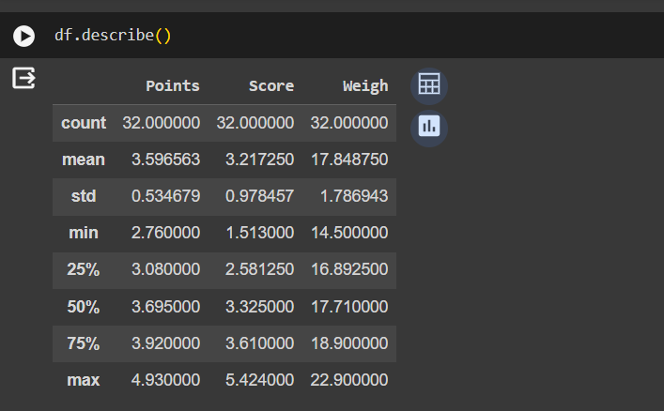

**Use Q7.csv file**

Q8) Calculate Expected Value for the problem below

1. The weights (X) of patients at a clinic (in pounds), are

108, 110, 123, 134, 135, 145, 167, 187, 199

Assume one of the patients is chosen at random. What is the Expected Value of the Weight of that patient?

Ans. Sum of Weights=1298

Total number of patients=9

Expected value = Sum of weights / Total number of patients = 1298 / 9 =144.223pounds

**Q9) Calculate Skewness, Kurtosis & draw inferences on the following data**

**Cars speed and distance**

**Use Q9_a.csv**

**Ans.** 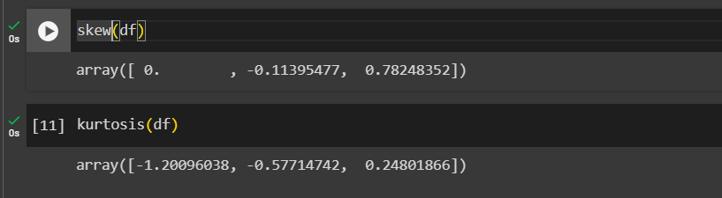

**SP and Weight(WT)**

**Use Q9_b.csv**

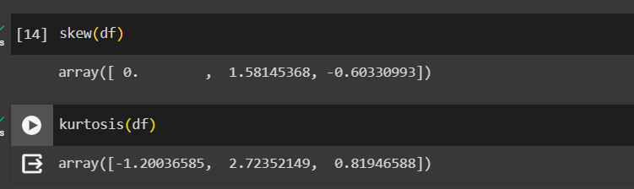

**Q10) Draw inferences about the following boxplot & histogram**



Chick weight data is right skewed or positively skewed.---- Yes

More than 50% Chick Weight is between 50 to 150. ---- Yes

Most of the chick weight is between 50 to 100. --- Yes



The data is right skewed. - There are outliers at upper side

**Q11)** Suppose we want to estimate the average weight of an adult male in Mexico. We draw a random sample of 2,000 men from a population of 3,000,000 men and weigh them. We find that the average person in our sample weighs 200 pounds, and the standard deviation of the sample is 30 pounds. Calculate 94%,98%,96% confidence interval?

Ans.

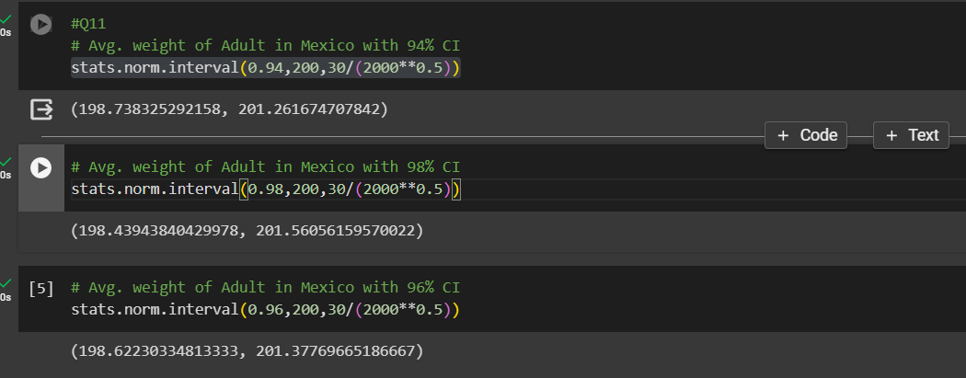

**Q12)** Below are the scores obtained by a student in tests

**34,36,36,38,38,39,39,40,40,41,41,41,41,42,42,45,49,56**

1. Find mean, median, variance, standard deviation.
2. What can we say about the student marks?

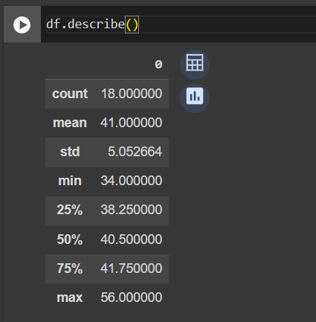

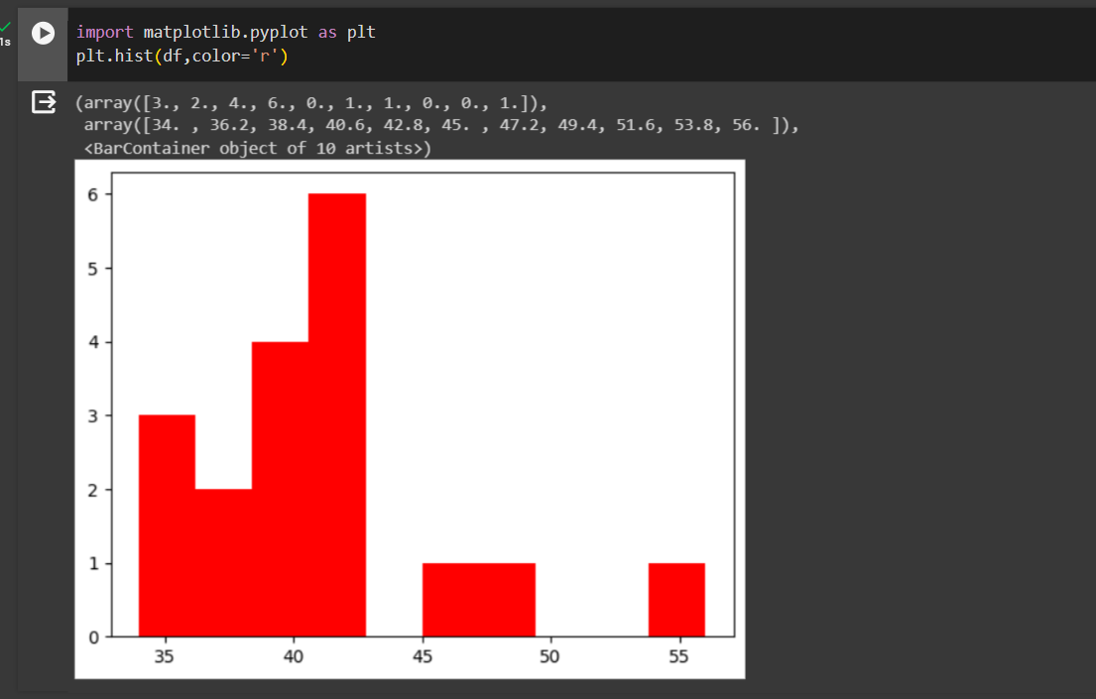

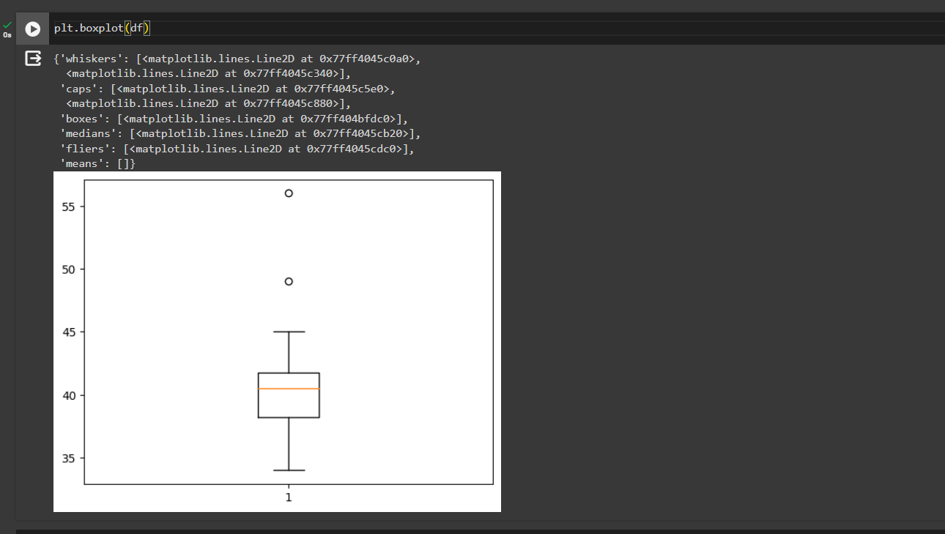

Sharper

*.*

Q13) What is the nature of skewness when mean, median of data are equal?

Ans. It is called Zero Skewed

Q14) What is the nature of skewness when mean > median ?

Ans. Right skewed distribution

Q15) What is the nature of skewness when median > mean?

Ans. left skewed distribution

Q16) What does positive kurtosis value indicates for a data ?

Ans It indicates that distribution has heavier tail and sharper peak than the normal distribution

Q17) What does negative kurtosis value indicates for a data?

Ans. It indicates that distribution has low tail and flat peak than the normal distribution

Q18) Answer the below questions using the below boxplot visualization.



What can we say about the distribution of the data?

Ans.Asymmetrical distribution

What is nature of skewness of the data?

Ans.Left skewed

What will be the IQR of the data (approximately)?

Ans.IQR=18-10=8

Q19) Comment on the below Boxplot visualizations?



Draw an Inference from the distribution of data for Boxplot 1 with respect Boxplot 2.

Ans.1)There is no outlier

2)Both box plot share same median range between 275-250 and they normally distribuited with zero

Q 20) Calculate probability from the given dataset for the below cases

Data _set: Cars.csv

Calculate the probability of MPG of Cars for the below cases.

MPG <- Cars$MPG

* 1. P(MPG>38)
  2. P(MPG<40)

c. P (20<MPG<50)

Ans. 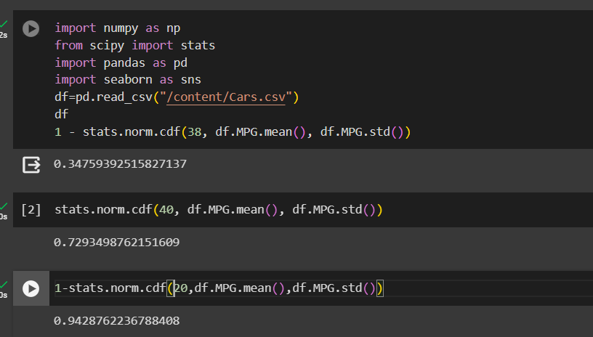

Q 21) Check whether the data follows normal distribution

1. Check whether the MPG of Cars follows Normal Distribution

Dataset: Cars.csv

­­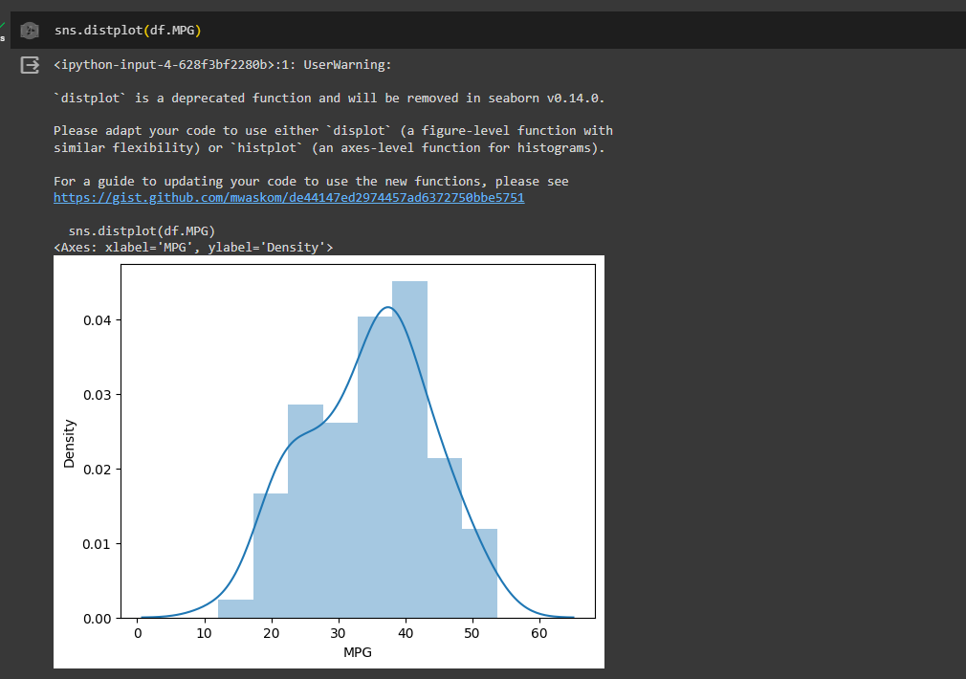

1. Check Whether the Adipose Tissue (AT) and Waist Circumference(Waist) from wc-at data set follows Normal Distribution

Dataset: wc-at.csv

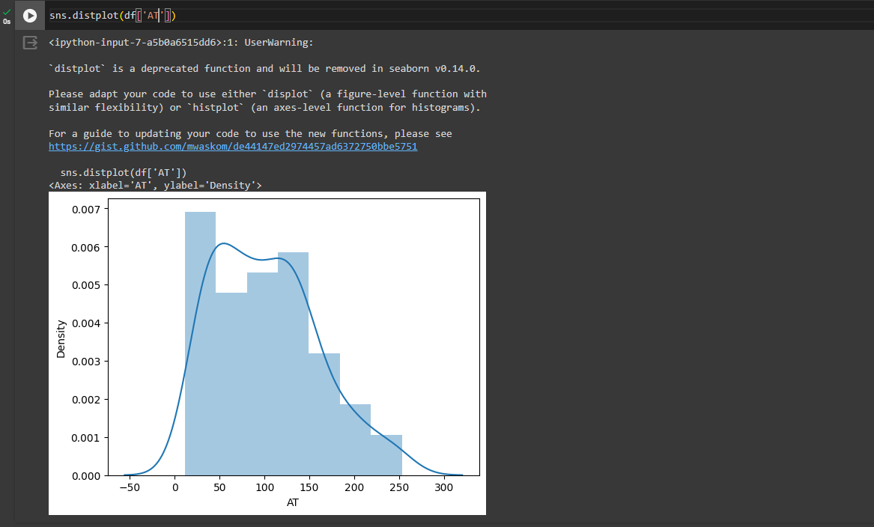

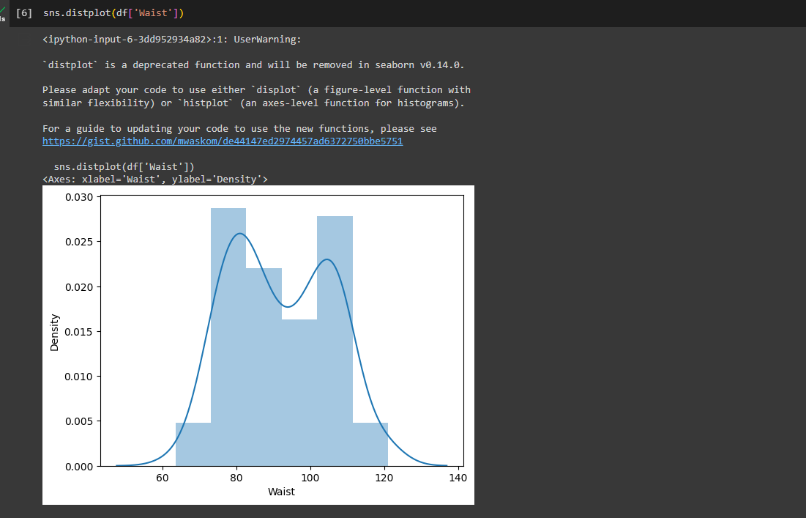

Q 22) Calculate the Z scores of 90% confidence interval,94% confidence interval, 60% confidence interval

Ans. 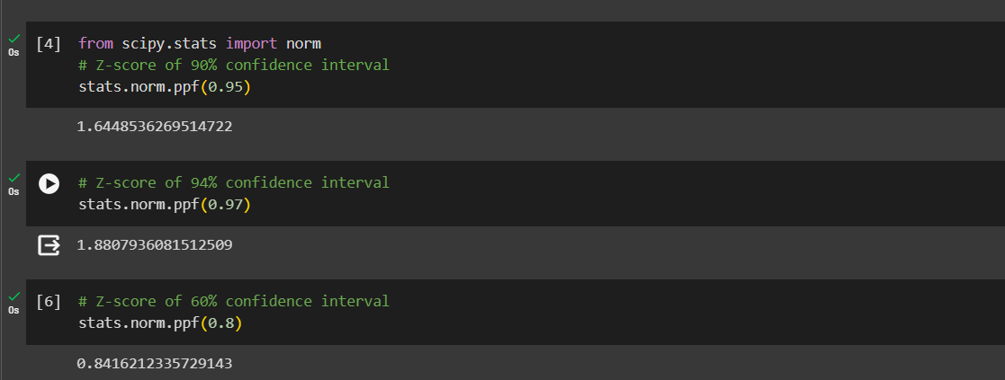

Q 23) Calculate the t scores of 95% confidence interval, 96% confidence interval, 99% confidence interval for sample size of 25

Ans 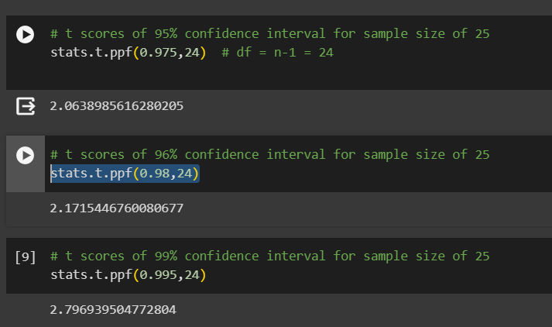

Q 24**)** A Government company claims that an average light bulb lasts 270 days. A researcher randomly selects 18 bulbs for testing. The sampled bulbs last an average of 260 days, with a standard deviation of 90 days. If the CEO's claim were true, what is the probability that 18 randomly selected bulbs would have an average life of no more than 260 days

Hint:

rcode 🡪 pt(tscore,df)

df 🡪 degrees of freedom

Ans.

